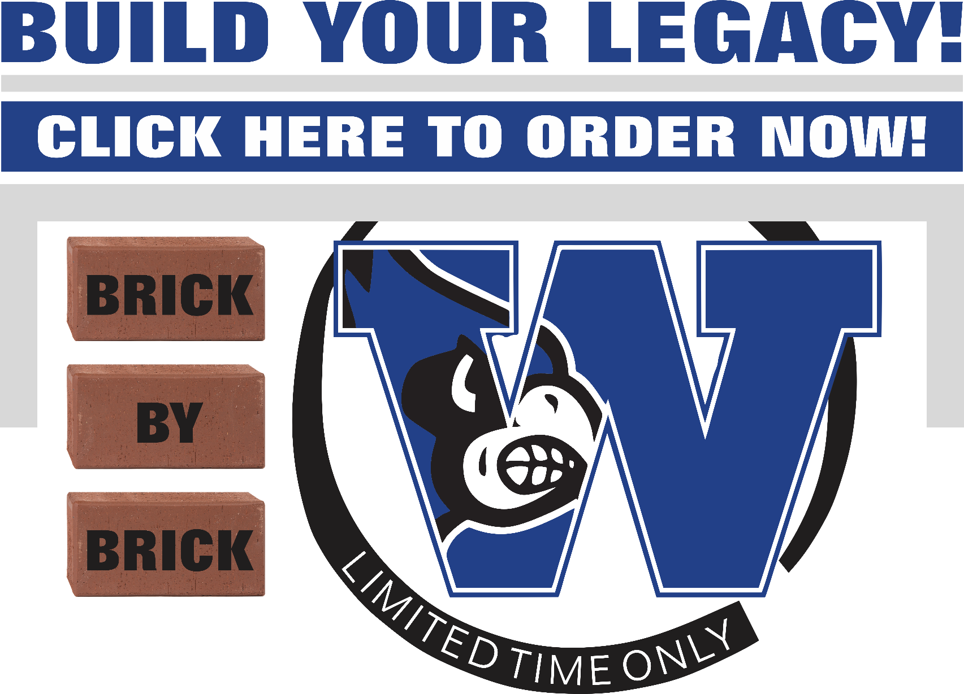

Dear Donor,

Through the Washington High School Build your Legacy Brick Program, you can be a permanent piece of the WHS for future generations. The bricks will be installed on the pavilion at Scanlan Stadium. Proceeds from this fundraiser will go to support the Washington High School Marketing program and the Four Rivers Career Center DECA Chapter.

With the purchase of the bricks, buy a brick in honor of your family; in memory of a loved one, recognize a student’s achievement, honor a staff member; commemorate a special occasion; buy a brick to leave an important message for future generations …the possibilities are endless.

Unlike other forms of donation, when you buy a brick, you become a visible part of our future. Something that serves as a source of solidarity and inspiration for others. There is no better way to achieve school community involvement, so please consider this distinctive opportunity and show your support by buying a brick today and leaving a legacy for a lifetime!

Order your brick today! https://www.fundraisingbrick.com/online-orders/whs/

Please direct questions to Katelyn Huber at 636-231-2800, or email katelyn.huber@sdowmo.org

Sincerely,

Katelyn Huber

WHS Brick Committee

