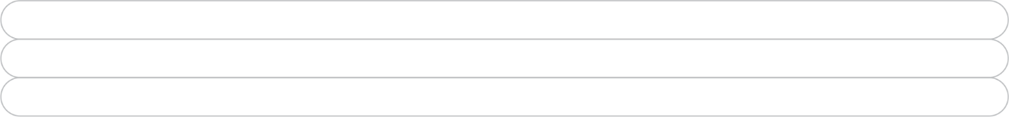

**Engraving Info. Special Note: 8X8 bricks DO NOT come with lugs. Chamfered Edge NO Lugs is the most used style.**

|  |  |
| --- | --- |
| Brick or Tile Shade: |  |
| Brick Style: | ☐ Chamfered Edge **NO** Lugs  ☐ Chamfered Edge **With** Lugs  ☐ Straight Edge No Lugs  ☐ Customer Supplied ☐ Other |
| Font Name & #: |  |
| Font Case Type: | ☐ All Caps ☐ Mixed Case As Typed |
| Clipart Location 4X8: | ☐ N/A ☐ Left of Text ☐ Right of Text |
| Clipart Location 8X8: | ☐ N/A ☐ Above Text ☐ Below Text |

Shipping Address is the same as Billing Address  
 **Verify liftgate and appointment below.**

**Billing Address All orders are Cash in Advance**

|  |  |
| --- | --- |
| Company: |  |
| Contact Name: |  |
| Full Address: |  |
| Phone Number: |  |
| Email: |  |

**Shipping Address**

|  |  |
| --- | --- |
| Company: |  |
| Contact Name: |  |
| Full Address: |  |
| Phone Number: |  |
| Email: |  |
| Lift Gate Needed: | Yes  No Appointment Required:  Yes  No |

**General Info.**

|  |  |
| --- | --- |
| Date: |  |
| Tax Exempt ID: |  |
| PO Number: |  |
| Signature: |  |

**Brick /Tile Quantity**

|  |  |  |
| --- | --- | --- |
|  |  | 4X8 |
|  |  | 8X8 |
|  |  | 4X8 Blanks |
|  |  | 8X8 Blanks |
|  |  | 4X8 Half Paver |
|  |  | Mini bricks 1X3 |
|  |  | Mini bricks 3X3 |
|  |  | Donor Certificates |
|  |  | Replica 4X8 |
|  |  | Replica 8X8 |
|  |  | Acrylic Display 4X8 |
|  |  | Acrylic Display 8X8 |

Please use designated word document forms or excel files to enter text as you want it to appear on the brick. All text will be centered unless otherwise stated on order.

Special Instructions or Notes please enter here:

|  |
| --- |
|  |
|  |
|  |

**BRICK & QUARRY TILE ORDER FORM**

**SPECIAL NOTE:**

If the shipping address provided is to a location that is NOT always open, the customer is responsible for the extra shipping charges that Fundraising Brick incurs when the shipment is returned.

A lift gate is required to lift brick pallets from delivery truck to ground. You do not need a lift gate if you have a loading dock or a fork truck. – If a lift gate is required $75 will be applied to your invoice and $40 for appointments.

**NOTE:** Once your order has been submitted, it is considered final.  Any additional bricks that are submitted later are considered a new order and are subject to additional fees. There is a lot of paperwork and time involved in generating an order, so to avoid any additional fees, make sure that you have all orders submitted and that changes are not required.