Dear Friend of Stray Rescue,

Brick by brick, we are saving the abandoned, the neglected, the homeless, and the betrayed underdogs and cats who need us most, and giving them the second chance at a loving life they deserve. We’re doing this with bricks and honoring the kindhearted people who make it possible for these brave and resilient animals to thrive.

When you take a stroll on the sidewalk at Stray Rescue next to the gardens, the beautiful messages and memories on each brick give such an incredible feeling of hope and love. These memorials add to a lasting monument that will continue uniting a compassionate community for years to come.

You are receiving this mini replica brick as a thank you for your donation to Stray Rescue of St. Louis. The mini paver is for you to keep, as we engrave your full size paver. The full size paver will be installed in our memorial walkway. They take a few weeks to a few months to come in. When it arrives, a representative from Stray Rescue will send you a photo so you’ll know when it’s been installed. If you have any questions, please do not hesitate to reach out to natalie@strayrescue.org.

Have a wonderful day and thank you again for your generous gift to Stray Rescue of St. Louis. We’re stronger together!

With Gratitude,

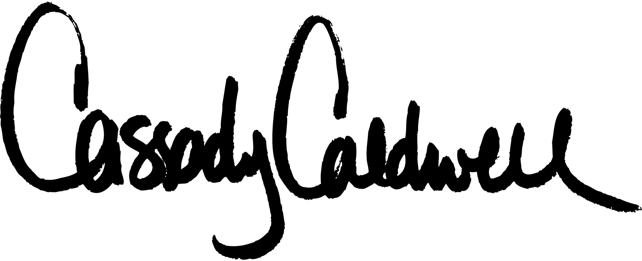

Cassady Caldwell, Executive Director Stray Rescue of St. Louis

